SIR SYED UNIVERSITY OF ENGINEERING & TECHNOLOGY
COMPUTER SCIENCE & INFORMATION TECHNOLOGY DEPARTMENT

Fall 2024
Web Engineering (CS311T)
Assignment # 3 Sec C

Semester: 5th Batches: 2022F, 2020F
Announced Date: Dec 10, 2024 Due Date: Dec 17, 2024
Total Marks: 10 Marks Obtained:
Instructor Name: Mohsin Ali
CLO # | Course Learning Outcomes (CLOs) | PLO Mapping | Bloom’s Taxonomy
CLO 2 | Apply JavaScript on the following given problem: | PLO_2  (Knowledge for solving Computing Problems) | C2  (Understanding)

Instructions:

- Complete the assignment in groups, each group must have maximum 4 students.
- Assignment should be submitted in the form of hard copy.
- You have to submit only program coding i.e. DO NOT RUN ON COMPUTER.
- Copying is not allowed. Any similar assignments will get zero marks.
- Insert this page on top of your assignment.

Group Members
Name | Roll Number
Saad Ali | 2022F-BCS-162
Muzamil | 2022F-BCS-316
Muhammad Faisal | 2022F-BCS-152
Afnan | 2022F-BCS-168

Problem :

Illustrate by a JavaScript program to display the following output of a form:

-------------------------------------------------------------------------------------------------------------------

ABC CORPORATION

Employees Data

Emp No
078

Hassan Ali
Name

Grade
10

Programmer

Designation

45,000
Salary

Mob No
0399-2233445

Home
Update
Submit

-------------------------------------------------------------------------------------------------------------------

Solution :

<!DOCTYPE html>
<html lang="en">
<head>
<meta charset="UTF-8">
<meta name="viewport" content="width=device-width, initial-scale=1.0">
<title>ABC Corporation - Employee Data</title>
<style>
body {
font-family: Arial, sans-serif;
background-color: #f4f4f9;
color: #333;
margin: 0;
padding: 20px;
}

.container {
max-width: 600px;
margin: 50px auto;
background: #fff;
padding: 20px 30px;
border-radius: 10px;
box-shadow: 0 4px 6px rgba(0, 0, 0, 0.1);
}

h1 {
text-align: center;
color: #333;
}

h2 {
text-align: center;
color: #555;
margin-bottom: 30px;
}

.form-group {
margin-bottom: 20px;
}

label {
display: block;
font-size: 14px;
font-weight: bold;
margin-bottom: 8px;
color: #555;
}

input[type="text"], input[type="number"] {
width: 100%;
padding: 10px;
border: 1px solid #ccc;
border-radius: 5px;
font-size: 14px;
box-sizing: border-box;
}

input[type="text"]:focus, input[type="number"]:focus {
border-color: #007BFF;
outline: none;
box-shadow: 0 0 5px rgba(0, 123, 255, 0.5);
}

.btn-group {
text-align: center;
margin-top: 20px;
}

.btn {
background-color: #007BFF;
color: #fff;
border: none;
padding: 10px 20px;
font-size: 16px;
border-radius: 5px;
cursor: pointer;
margin: 5px;
transition: background-color 0.3s ease;
}

.btn:hover {
background-color: #0056b3;
}

.btn-secondary {
background-color: #6c757d;
}

.btn-secondary:hover {
background-color: #5a6268;
}
</style>
</head>
<body>
<div class="container">
<h1>ABC CORPORATION</h1>
<h2>Employees Data</h2>
<form id="employeeForm">
<div class="form-group">
<label for="empNo">Employee Number</label>
<input type="text" id="empNo" name="empNo" placeholder="Enter Employee Number" value="078" required>
</div>
<div class="form-group">
<label for="name">Name</label>
<input type="text" id="name" name="name" placeholder="Enter Name" value="Hassan Ali" required>
</div>
<div class="form-group">
<label for="grade">Grade</label>
<input type="number" id="grade" name="grade" placeholder="Enter Grade" value="10" required>
</div>
<div class="form-group">
<label for="designation">Designation</label>
<input type="text" id="designation" name="designation" placeholder="Enter Designation" value="Programmer" required>
</div>
<div class="form-group">
<label for="salary">Salary</label>
<input type="text" id="salary" name="salary" placeholder="Enter Salary" value="45000" required>
</div>
<div class="form-group">
<label for="mobNo">Mobile Number</label>
<input type="text" id="mobNo" name="mobNo" placeholder="Enter Mobile Number" value="0399-2233445" required>
</div>
<div class="btn-group">
<button type="button" class="btn" onclick="submitForm()">Submit</button>
<button type="button" class="btn" onclick="updateForm()">Update</button>
<button type="button" class="btn btn-secondary" onclick="goHome()">Home</button>
</div>
</form>
</div>

<script>
function submitForm() {
const form = document.getElementById('employeeForm');
const formData = new FormData(form);
alert("Form Submitted: \n" + Array.from(formData.entries()).map(([key, value]) => `${key}: ${value}`).join("\n"));
}

function updateForm() {
alert("Form Updated!");
}

function goHome() {
alert("Redirecting to Home...");
}
</script>
</body>
</html>

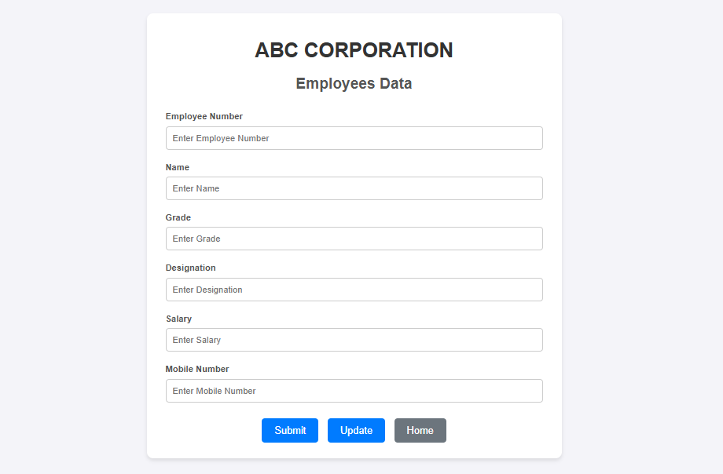

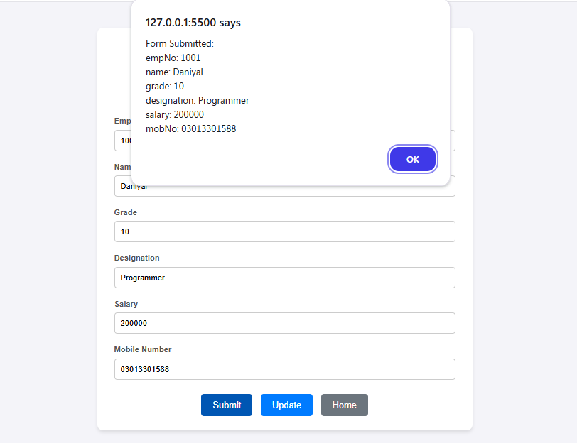
- Form Submitted

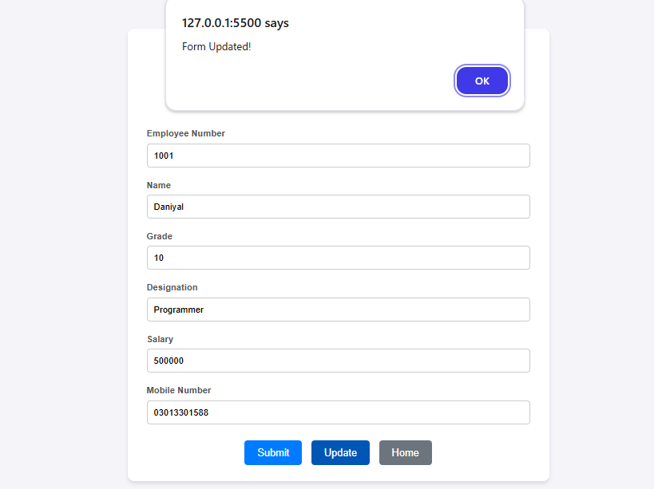
- Form Updated

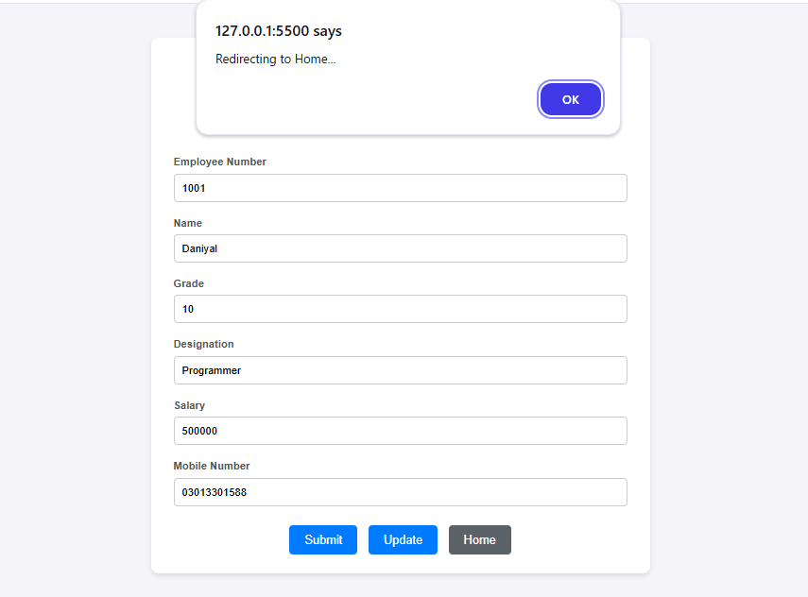
- Redirecting to Home

